
Live Test 09/29 B
Platform Holistic Review
Prepared for Minnesota Department of Education — School Finance
by Ledelsea · September 29, 2026
VERDICT  Replatform (patch) | OVERALL SCORE  76/100 | TOTAL RISK  Critical | CONFIDENCE  Medium

Contents
1. Executive summary
2. Current state
3. Technical state & health
4. Total risk & risk-impact matrix
5. Security analysis & vulnerabilities
6. UI, process & website review
7. End-of-life & supportability
8. Technical debt
9. Potential solutions & modernization roadmap
10. Diagrams
11. Coverage, confidence & method

1. Executive summary
Replatform PATCH · confidence medium
Live Test 09/29 B is assessed as Replatform (patch), with medium confidence. Upgrade runtime/framework to a supported version with targeted code changes. The scan found 1 critical and 2 high-severity security issues, several in code that handles student data (FERPA scope). 1 technology is past end of life or have no supported upgrade path. 1 of 5 components carry high or critical risk; the highest is 3_district_aid_lookup.html. The recommended roadmap is estimated at 4.0–12.5 person-weeks (about 1–3 months for one developer).
OVERALL SCORE | TOTAL RISK | CRITICAL / HIGH FINDINGS | UNSUPPORTED TECHNOLOGIES | ROADMAP EFFORT | CAPTURED
76/100 | Critical | 1 / 2 | 1 | 4.0–12.5 person-weeks | 5 files · 96% of referenced code

Why this verdict
- 23% of the code runs on end-of-life or dead-end technology: jQuery 1: end of life
- Rebuild or move those components (see component dispositions); keep the rest

Highest-risk components
Component | Risk | Score | Disposition | Student data
3_district_aid_lookup.html | Critical (5×4) | 70 | Replatform | yes
2_AIDPOST.rpgle | Low (1×4) | 94 | Retain
1_AIDPAYRN.cbl | Low (1×4) | 99 | Retain
4_aidinq_3270_SCREEN.html | Low (1×3) | 96 | Retain
AIDDBD-live.dbd | Low (1×2) | 97 | Retain

Recommended first actions
Action | Effort (person-weeks) | Where
Capture 4 missing component(s) | 0.2–0.5 | program-wide
Confirm business criticality | 0.1–0.2 | program-wide
Encrypt connections | 0.8–2.0 | 3_district_aid_lookup.html
Remove hard-coded credentials | 0.7–1.5 | 3_district_aid_lookup.html
Harden UI security | 0.2–1.0 | 3_district_aid_lookup.html

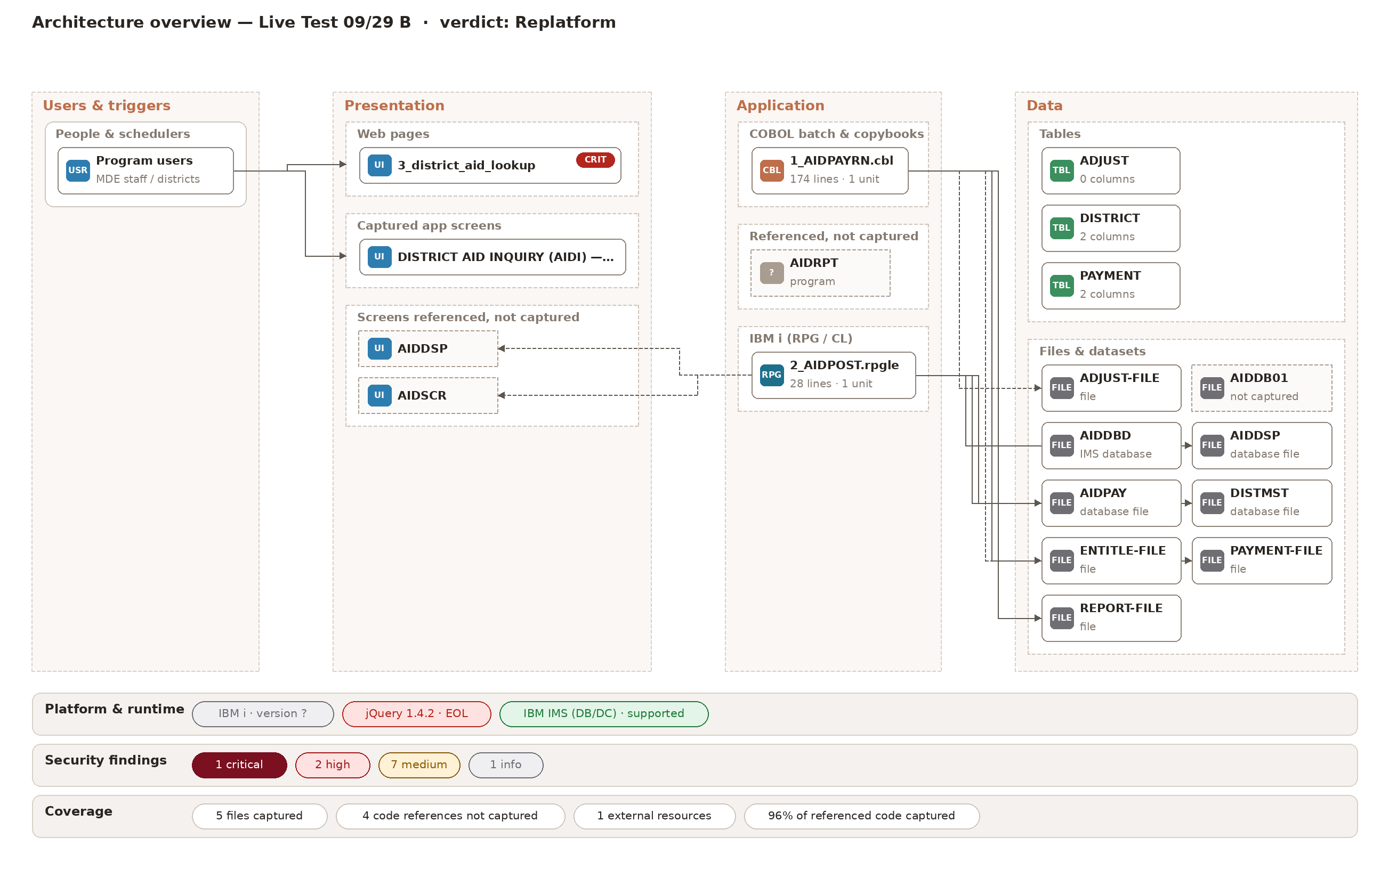
Architecture overview — Live Test 09/29 B · verdict: Replatform. Every captured component by layer, with risk and end-of-life badges; platform, configuration, security and coverage along the bottom.

2. Current state
5 files were captured from screenshots and turned into a model of 106 program elements. Every fact in this report links back to the screenshot it came from.
Language / type | Files | Examples
COBOL | 1 | 1_AIDPAYRN.cbl
RPG | 1 | 2_AIDPOST.rpgle
HTML | 1 | 3_district_aid_lookup.html
UI screen | 1 | 4_aidinq_3270_SCREEN.html
Assembler | 1 | AIDDBD-live.dbd

PROGRAM | PARAGRAPH | SCREEN | TABLE | DATA STORE
2 | 10 | 2 | 3 | 8

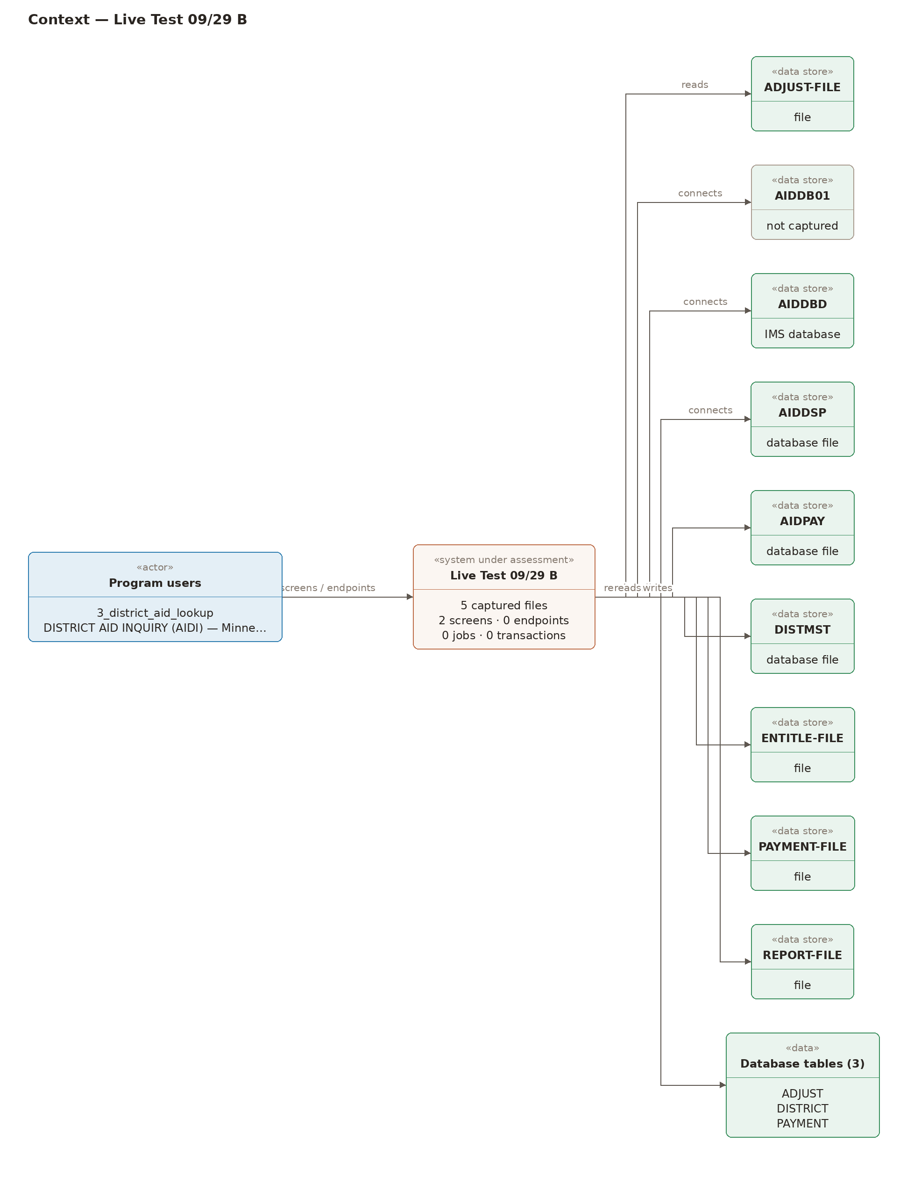
Context — Live Test 09/29 B. The program as one system: who uses it, what triggers it, and every external system and data store it touches.

3. Technical state & health
Each component is scored 0–100 on six dimensions (100 = best). Every point deducted is listed below with the rule and finding that caused it. good ≥80 · fair ≥60 · poor ≥40 · critical <40.
Dimension | Score | Grade | Weakest component
Health | 99 | Good | 2_AIDPOST.rpgle (88)
Tech debt | 93 | Good | 2_AIDPOST.rpgle (79)
Security | 25 | Critical | 3_district_aid_lookup.html (0)
Supportability | 87 | Good | 3_district_aid_lookup.html (65)
Complexity | 100 | Good | 1_AIDPAYRN.cbl (100)
Coupling | 100 | Good | 1_AIDPAYRN.cbl (100)
UX & accessibility | 81 | Good | 3_district_aid_lookup.html (40)

Scores by component
Component | Language | Lines | Health | Tech debt | Security | Supportability | Complexity | Coupling | UX & accessibility
1_AIDPAYRN.cbl | COBOL | 169 | 100 | 100 | 100 | 90 | 100 | 100 | 100
2_AIDPOST.rpgle | RPG | 27 | 88 | 79 | 100 | 88 | 100 | 100 | 100
3_district_aid_lookup.html | HTML | 102 | 100 | 86 | 0 | 65 | 100 | 100 | 40
4_aidinq_3270_SCREEN.html | UI screen | 124 | 100 | 93 | 100 | 100 | 100 | 100 | 80
AIDDBD-live.dbd | Assembler | 13 | 95 | 93 | 100 | 90 | 100 | 100 | 100

Largest deductions
Component | Dimension | Points | Reason
3_district_aid_lookup.html | Supportability | -35 | jQuery 1: end of life
3_district_aid_lookup.html | Security | -25 | Hard-coded credential: 3_district_aid_lookup.html:8
3_district_aid_lookup.html | Security | -15 | Data sent without encryption: 3_district_aid_lookup.html:6
3_district_aid_lookup.html | Security | -15 | Sensitive data sent in the URL: 3_district_aid_lookup.html:32
3_district_aid_lookup.html | Security | -15 | Mixed / plain-HTTP content: 3_district_aid_lookup.html:6
2_AIDPOST.rpgle | Health | -12 | calls 4 program(s)/class(es) not captured
3_district_aid_lookup.html | Security | -10 | high-severity issue in a component that handles student data (FERPA)
2_AIDPOST.rpgle | Supportability | -10 | RPG / IBM i skills are scarce — support depends on a shrinking MNIT/vendor pool
1_AIDPAYRN.cbl | Supportability | -10 | COBOL/CICS skills are scarce — support depends on a shrinking MNIT/vendor pool
AIDDBD-live.dbd | Supportability | -10 | mainframe assembler skills are scarce — support depends on a shrinking MNIT/vendor pool

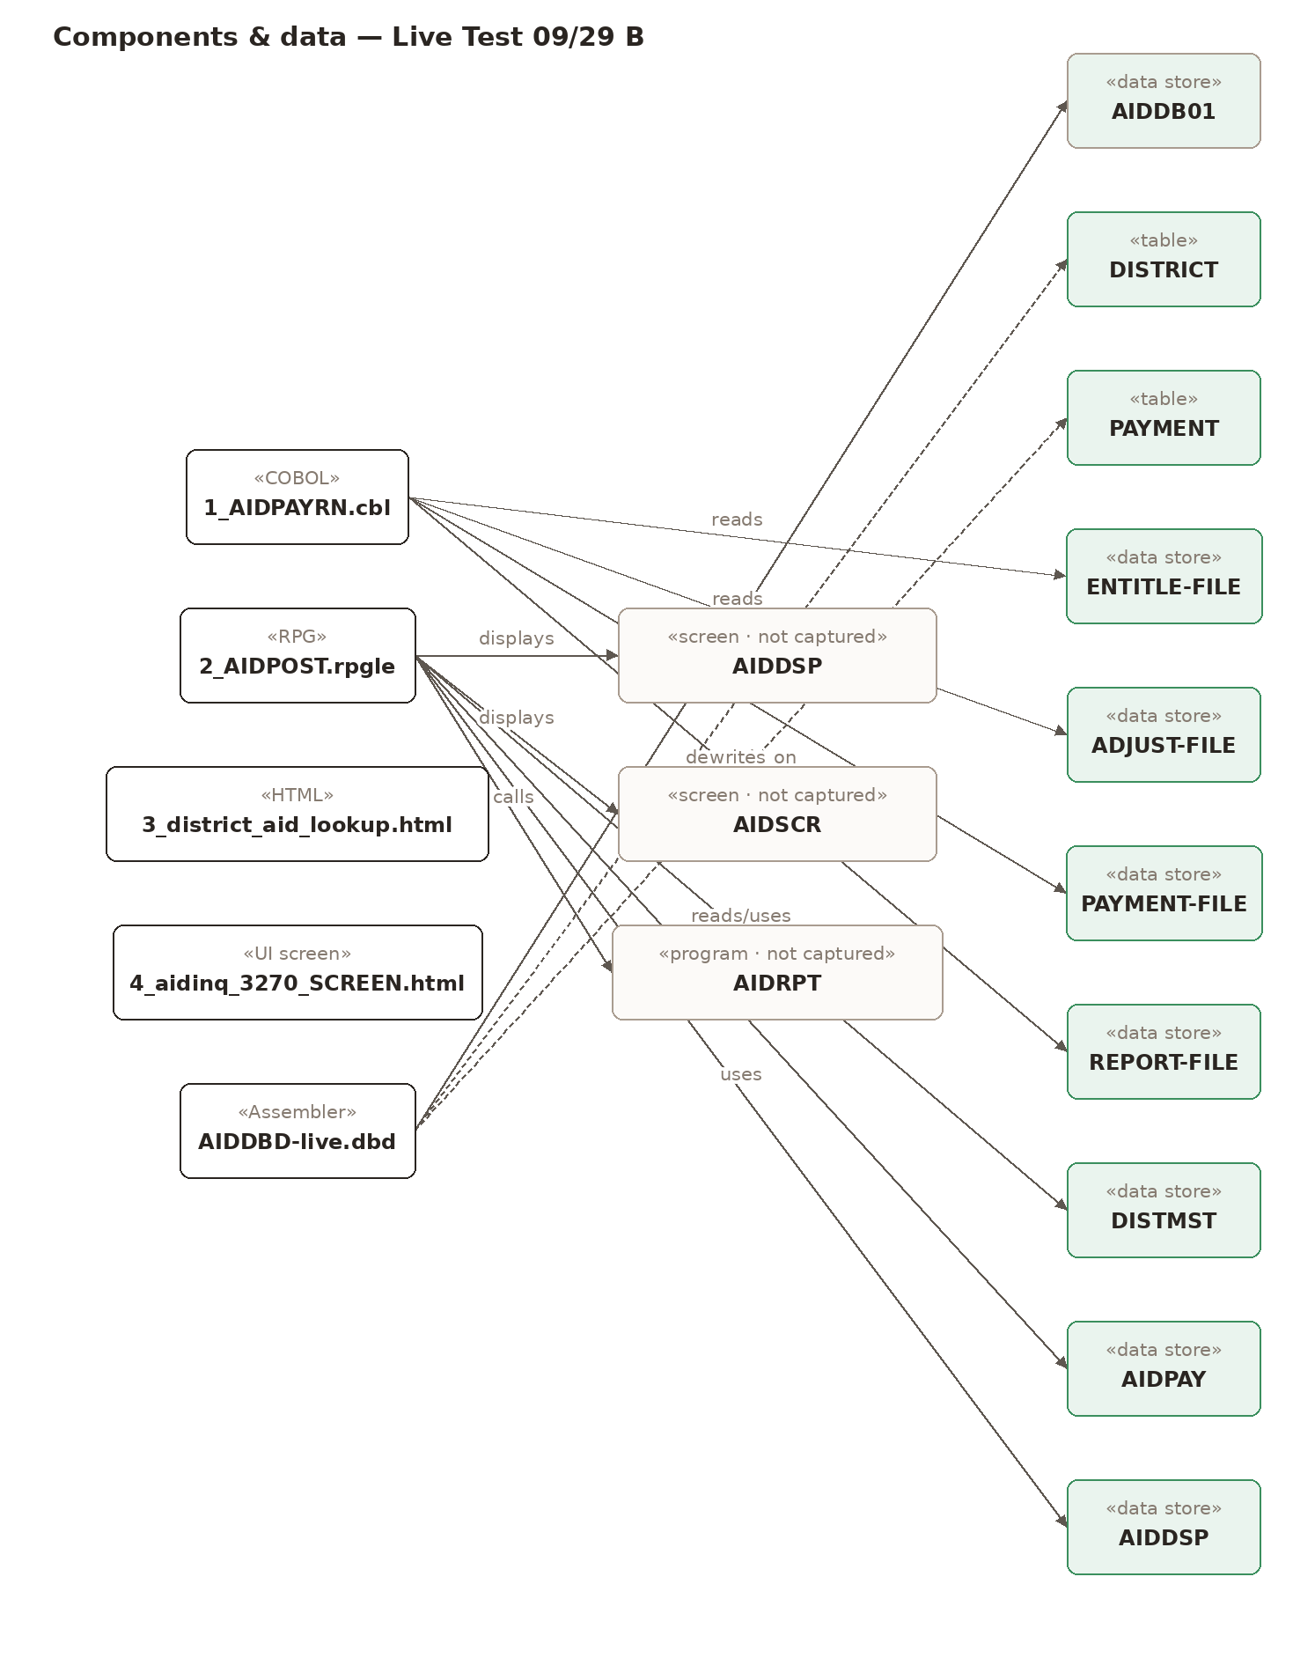
Components & data — Live Test 09/29 B. Every captured file, what it depends on, and the data it reads and writes. Dashed = referenced but not captured.

4. Total risk & risk-impact matrix
Total risk is critical. Likelihood comes from each component's weakest security, supportability and health scores; impact comes from MDE's criticality rating, or a default where none has been entered yet.
Likelihood ↓ / Impact →
5 |  |  |  | 1: 3_district_aid_lookup.html
4
3
2
1 |  | 1: AIDDBD-live.dbd | 1: 4_aidinq_3270_SCREEN.html | 2: 1_AIDPAYRN.cbl, 2_AIDPOST.rpgle
 | 1 | 2 | 3 | 4 | 5

Component | Likelihood | Impact | Level | Impact source
3_district_aid_lookup.html | 5 | 4 | Critical | default (handles student data)
2_AIDPOST.rpgle | 1 | 4 | Low | default (writes program data)
1_AIDPAYRN.cbl | 1 | 4 | Low | default (writes program data)
4_aidinq_3270_SCREEN.html | 1 | 3 | Low | default (user- or job-facing entry point)
AIDDBD-live.dbd | 1 | 2 | Low | default (supporting component)

5. Security analysis & vulnerabilities
CRITICAL | HIGH | MEDIUM | LOW | INFO
1 | 2 | 7 | 0 | 1

Findings come from deterministic rules over the transcribed code and configuration, a CVE check of versioned libraries, and a student-data classifier. Issues in code or connections that handle student data are raised one level and tagged FERPA / Minn. Stat. ch. 13. Secrets are masked.
Severity | Finding | Location | Evidence | Standards
Critical | Hard-coded credential | 3_district_aid_lookup.html:8 | var apiKey = "****"; | CWE-798, NIST IA-5(7), NIST IA-5, FERPA, MN ch.13
High | Data sent without encryption | 3_district_aid_lookup.html:6 | <script type="text/javascript" src="http://code.jquery.com/jquery-1.4.2.min.js"></script> | CWE-319, NIST SC-8, NIST SC-8(1), FERPA, MN ch.13
Medium | CVE-2012-6708 in jQuery 1.4.2 | 3_district_aid_lookup.html | jquery 1.4.2 | CVE-2012-6708, CWE-1395, NIST RA-5, NIST SI-2
Medium | CVE-2015-9251 in jQuery 1.4.2 | 3_district_aid_lookup.html | jquery 1.4.2 | CVE-2015-9251, CWE-1395, NIST RA-5, NIST SI-2
Medium | CVE-2019-11358 in jQuery 1.4.2 | 3_district_aid_lookup.html | jquery 1.4.2 | CVE-2019-11358, CWE-1395, NIST RA-5, NIST SI-2
Medium | CVE-2020-11022 in jQuery 1.4.2 | 3_district_aid_lookup.html | jquery 1.4.2 | CVE-2020-11022, CWE-1395, NIST RA-5, NIST SI-2
Medium | CVE-2020-11023 in jQuery 1.4.2 | 3_district_aid_lookup.html | jquery 1.4.2 | CVE-2020-11023, CWE-1395, NIST RA-5, NIST SI-2
Medium | Unencoded user input written to the page | 3_district_aid_lookup.html:12 | document.getElementById("result").innerHTML = "Searching for " + id + "..."; | CWE-79, NIST SI-10, NIST SI-15, FERPA, MN ch.13
Medium | Unencoded user input written to the page | 3_district_aid_lookup.html:17 | document.write("Student SSN: " + ssn); | CWE-79, NIST SI-10, NIST SI-15, FERPA, MN ch.13

Student and personal data
- No student data fields were identified in the captured files.

6. UI, process & website review
ACCESSIBILITY | USABILITY | UI SECURITY | WEBSITE
15 | 7 | 3 | 0

Page source (HTML/ASPX/JSP) is checked against WCAG 2.1 AA / Section 508 rules and for UI-level security issues; captured app screens are checked for visible errors, unlabeled fields and student data shown in full. Items marked vision were observed by the screen reader model and should be confirmed by a person; live items come from the website scan.

Accessibility
Severity | Issue | Location | Detail | Standard | From
Medium | Form field without a label | 3_district_aid_lookup.html:36 | Form field 'distId' has no programmatic label. | WCAG 1.3.1 / 3.3.2 / 4.1.2 (A) | source
Medium | Form field without a label | 3_district_aid_lookup.html:42 | Form field 'fy' has no programmatic label. | WCAG 1.3.1 / 3.3.2 / 4.1.2 (A) | source
Medium | Form field without a label | 3_district_aid_lookup.html:53 | Form field 'aidType' has no programmatic label. | WCAG 1.3.1 / 3.3.2 / 4.1.2 (A) | source
Medium | Form field without a label | 3_district_aid_lookup.html:54 | Form field 'aidType' has no programmatic label. | WCAG 1.3.1 / 3.3.2 / 4.1.2 (A) | source
Medium | Form field without a label | 3_district_aid_lookup.html:55 | Form field 'aidType' has no programmatic label. | WCAG 1.3.1 / 3.3.2 / 4.1.2 (A) | source
Medium | Form field without a label | 3_district_aid_lookup.html:61 | Form field 'pwd' has no programmatic label. | WCAG 1.3.1 / 3.3.2 / 4.1.2 (A) | source
Medium | Image without text alternative | 3_district_aid_lookup.html:29 | Image has no text alternative. | WCAG 1.1.1 Non-text Content (A) | source
Medium | Low text contrast — PF key legend is shown in dim, low-contrast green against the black background | 4_aidinq_3270_SCREEN.html | Observed on screen: PF key legend is shown in dim, low-contrast green against the black background. | WCAG 1.4.3 (AA) | vision
Medium | Low text contrast | 3_district_aid_lookup.html:30 | Text contrast 4.0:1 is below 4.5:1. | WCAG 1.4.3 Contrast (Minimum) (AA) | source
Low | No headings | 3_district_aid_lookup.html:1 | Form page has no headings to navigate by. | WCAG 1.3.1 / 2.4.6 (AA) | source
Low | Obsolete presentational HTML | 3_district_aid_lookup.html:30 | Presentational/obsolete HTML: font. | WCAG 1.3.1 Info and Relationships (A) | source
Low | Page language not declared | 3_district_aid_lookup.html:1 | Page language not declared (<html lang>) | WCAG 3.1.1 Language of Page (A) | source
Low | Table without headers | 3_district_aid_lookup.html:33 | Table has no header cells (<th>) — layout table or unlabeled data. | WCAG 1.3.1 Info and Relationships (A) | source
Low | Table without headers | 3_district_aid_lookup.html:74 | Table has no header cells (<th>) — layout table or unlabeled data. | WCAG 1.3.1 Info and Relationships (A) | source
Low | Unclear link text | 3_district_aid_lookup.html:68 | Link text 'click here' does not describe its target. | WCAG 2.4.4 Link Purpose (A) | source

Usability & visible bugs
Severity | Issue | Location | Detail | Standard | From
Low | Observed usability problem — Abbreviated labels (HOLDBACK PCT, FWD) are used | 4_aidinq_3270_SCREEN.html | Observed on screen: Abbreviated labels (HOLDBACK PCT, FWD) are used. |  | vision
Low | Observed usability problem — Holdback percentage is editable on an inquiry screen, so it is unclear whether this screen | 4_aidinq_3270_SCREEN.html | Observed on screen: Holdback percentage is editable on an inquiry screen, so it is unclear whether this screen |  | vision
Low | Observed usability problem — Input fields are marked only by underlining, so they are hard to tell apart from display-o | 4_aidinq_3270_SCREEN.html | Observed on screen: Input fields are marked only by underlining, so they are hard to tell apart from display-o |  | vision
Low | Observed usability problem — Screen codes (AIDI, AIDA) are cryptic and have no descriptive labels | 4_aidinq_3270_SCREEN.html | Observed on screen: Screen codes (AIDI, AIDA) are cryptic and have no descriptive labels. |  | vision
Low | Observed usability problem — The table has no visible currency unit or symbol | 4_aidinq_3270_SCREEN.html | Observed on screen: The table has no visible currency unit or symbol. |  | vision
Low | Observed usability problem — Two-digit year dates (MM/DD/YY) are mixed with a four-digit fiscal year field | 4_aidinq_3270_SCREEN.html | Observed on screen: Two-digit year dates (MM/DD/YY) are mixed with a four-digit fiscal year field. |  | vision
Low | Observed usability problem — Warning message uses a cryptic code (AID0142W) and points to another screen (AIDA) by code | 4_aidinq_3270_SCREEN.html | Observed on screen: Warning message uses a cryptic code (AID0142W) and points to another screen (AIDA) by code |  | vision

UI & website security
Severity | Issue | Location | Detail | Standard | From
High | Mixed / plain-HTTP content | 3_district_aid_lookup.html:6 | Script loaded over plain HTTP (mixed content) | CWE-319 | source
High | Sensitive data sent in the URL | 3_district_aid_lookup.html:32 | Form sends sensitive fields in the URL (GET): pwd. | CWE-598 | source
Medium | Password shown as typed | 3_district_aid_lookup.html:61 | Password field 'pwd' is not masked. | CWE-549 | source

Live website scan
No live scan has been run. Enter the program's URL in the UI & website panel to add TLS, header, cookie and page checks.

User journeys
- No multi-screen journeys found in the captured screens.
- Standalone screens (no navigation captured): 3_district_aid_lookup
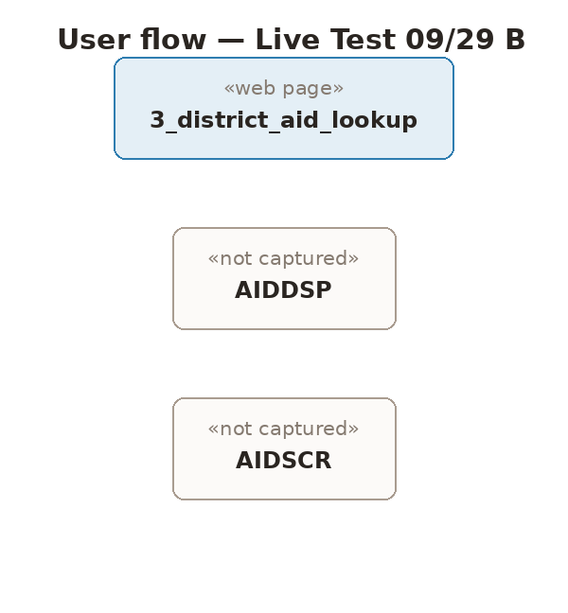
User flow — Live Test 09/29 B. How users move between screens (links, form submits, CICS XCTL/LINK). Dashed = screen referenced but not captured.

7. End-of-life & supportability
Support dates come from a bundled endoflife.date snapshot plus vendor notices for technologies it does not track. Versions marked unconfirmed need a build or server configuration capture to confirm.
Technology | Version | Status | End of life | Basis | Files
IBM i |  | Version not confirmed |  | RPG (IBM i) source detected (QCMDEXC command strings, RPG cycle / indicators (*INxx)) | 2_AIDPOST.rpgle
jQuery | 1.4.2 | End of life |  | script / library reference | 3_district_aid_lookup.html
IBM IMS (DB/DC) |  | Supported |  | IMS DBD source detected (IMS hierarchical database) | AIDDBD-live.dbd

8. Technical debt
Legacy constructs, machine-translated COBOL, GO TO usage, oversized files and routines. These drive the refactor items in the roadmap.
Component | Points | Debt item
3_district_aid_lookup.html | -7 | legacy construct: jQuery 1.4.2 (known XSS issues before 3.5)
3_district_aid_lookup.html | -7 | legacy construct: doctype DTD HTML 4.01 Transitional
2_AIDPOST.rpgle | -7 | legacy construct: QCMDEXC command strings
2_AIDPOST.rpgle | -7 | legacy construct: RPG cycle / indicators (*INxx)
2_AIDPOST.rpgle | -7 | legacy construct: fixed-form RPG (column-sensitive)
4_aidinq_3270_SCREEN.html | -7 | legacy construct: 3270 terminal
AIDDBD-live.dbd | -7 | legacy construct: IMS hierarchical database

9. Potential solutions & modernization roadmap
Estimated total: 4.0–12.5 person-weeks. Ranges come from rules per fix type and file size; MDE and Ledelsea should adjust them with local rates and staffing.

Phase 0 — Complete the assessment · Weeks 0–2 · 0.3–0.7 person-weeks
Item | What to do | Effort | Components
Capture 4 missing component(s) | Screenshot the programs/classes referenced but not yet captured so the verdict covers the whole program. | 0.2–0.5
Confirm business criticality | MDE staff rate each component's criticality and failure impact (1–5) on the Assessment panel. | 0.1–0.2

Phase 1 — Stabilize & secure · Months 0–3 · 1.5–4.5 person-weeks
Item | What to do | Effort | Components
Encrypt connections | Enable TLS for service endpoints and database connections (Encrypt=True, https). | 0.8–2.0 | 3_district_aid_lookup.html
Remove hard-coded credentials | Move secrets to a vault or protected configuration and rotate every exposed password. | 0.7–1.5 | 3_district_aid_lookup.html
Harden UI security | POST sensitive forms, add anti-forgery tokens, mask passwords and student identifiers, remove trusted values from hidden fields. | 0.2–1.0 | 3_district_aid_lookup.html

Phase 2 — Remediate · Months 3–9 · 2.0–7.5 person-weeks
Item | What to do | Effort | Components
Fix accessibility (WCAG 2.1 AA) | Add labels, text alternatives, page titles/language, keyboard access and contrast fixes; test with a screen reader. | 0.8–3.0 | 3_district_aid_lookup.html, 4_aidinq_3270_SCREEN.html
Usability fixes | Clear labels and buttons, input validation, confirmation steps for consequential actions, legends for codes. | 0.3–2.0 | 4_aidinq_3270_SCREEN.html
Upgrade jQuery to 3.7+ | Upgrade with jquery-migrate, then remove deprecated calls. | 0.5–1.5 | 3_district_aid_lookup.html
Encode output | HTML-encode user input before writing it to pages; re-enable request validation. | 0.2–0.6 | 3_district_aid_lookup.html
Harden UI security | POST sensitive forms, add anti-forgery tokens, mask passwords and student identifiers, remove trusted values from hidden fields. | 0.1–0.5 | 3_district_aid_lookup.html

Component dispositions
Component | Disposition | Why
3_district_aid_lookup.html | Replatform | Runs on an end-of-life runtime with a supported successor: jQuery 1: end of life; Code is workable (tech debt 86/100)
2_AIDPOST.rpgle | Retain | All scores fair or better (security 100, supportability 88, health 88, tech debt 79); No critical or high security findings open
1_AIDPAYRN.cbl | Retain | All scores fair or better (security 100, supportability 90, health 100, tech debt 100); No critical or high security findings open
4_aidinq_3270_SCREEN.html | Retain | All scores fair or better (security 100, supportability 100, health 100, tech debt 93); No critical or high security findings open
AIDDBD-live.dbd | Retain | All scores fair or better (security 100, supportability 90, health 95, tech debt 93); No critical or high security findings open

10. Diagrams
All diagrams are generated from the program model, not drawn by hand or by AI. The full set, including one class diagram per file, is in the accompanying Visio (.vsdx) and draw.io files.
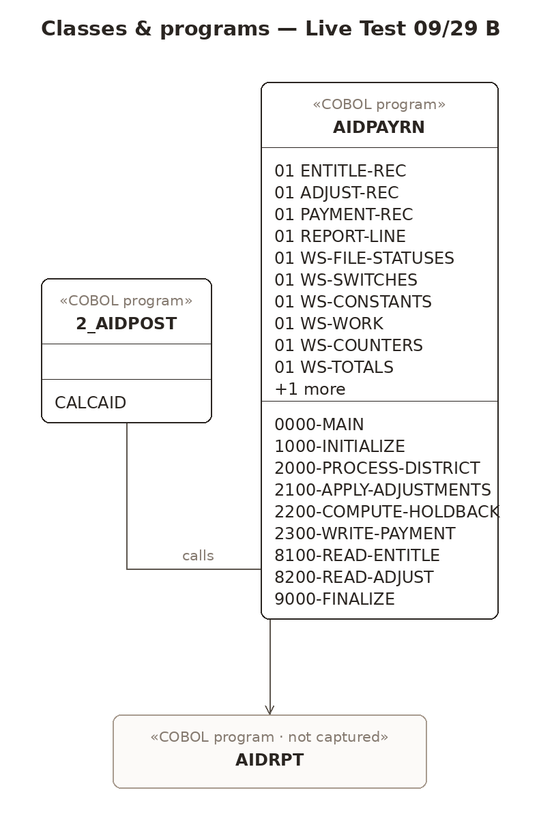
Classes & programs — Live Test 09/29 B. Classes and COBOL programs with their fields and routines; inheritance, calls and copybook includes.
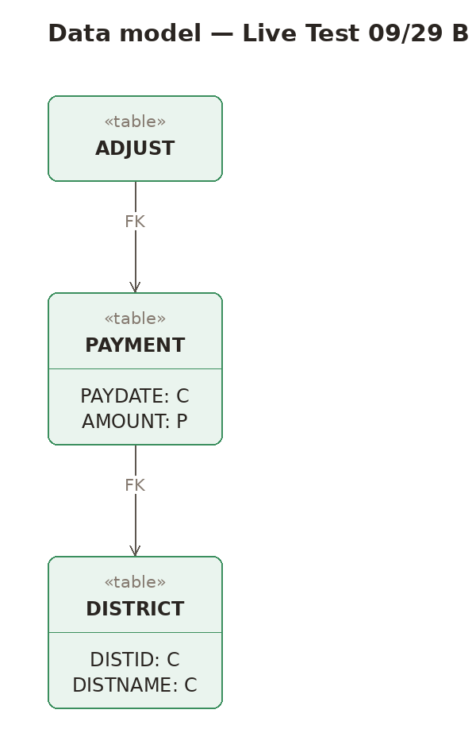
Data model — Live Test 09/29 B. Tables with columns and keys. Dashed tables are used by code but no DDL was captured.

11. Coverage, confidence & method
CONFIDENCE | REFERENCED CODE CAPTURED | MISSING CODE REFERENCES | EXTERNAL RESOURCES
Medium | 96% | 4 | 1

- 96% of referenced code captured (4 missing)
- 1 technology version(s) unconfirmed
- business criticality not entered — impact uses defaults

Referenced but not captured
- paragraph CALCAID — used by 2_AIDPOST.rpgle
- program AIDRPT — used by 2_AIDPOST.rpgle
- screen AIDDSP — used by 2_AIDPOST.rpgle
- screen AIDSCR — used by 2_AIDPOST.rpgle

Analyst corrections
Date | Change | Note
— | No corrections applied — the model is exactly as extracted.

Method
- Code, screens, schemas and configuration were captured as screenshots and transcribed with a vision model; transcriptions were syntax-checked with real compilers/parsers (GnuCOBOL, tree-sitter).
- Program structure, security rules, end-of-life matching, scoring, verdict and diagrams are deterministic code — the same inputs always give the same report.
- End-of-life data: endoflife.date snapshot 2026-09-25 plus vendor notices; CVEs: OSV (when online) or a curated list.
- Nothing was executed against MDE systems; findings should be confirmed with MNIT before remediation.

